Comparator Prob. # - Sorting: Comparator (Non-bool type and using a class)
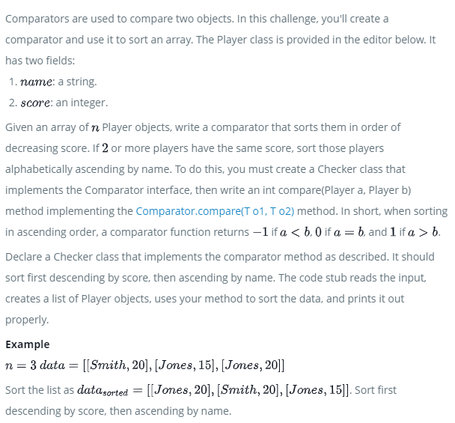
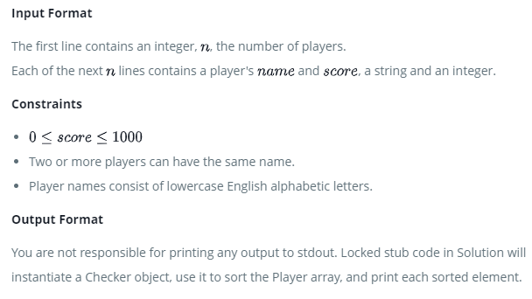

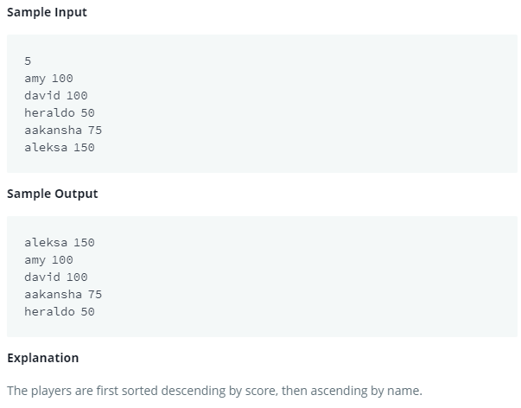
Note: Amy and David have equal scores so they are sorted in ascending order of their names.

